Intelligent Next Best Action Platform using Agentic AI
1. Introduction
Modern B2B SaaS companies manage hundreds of customers simultaneously. Every customer generates large amounts of information in the form of emails, support tickets, meeting notes, CRM updates, contracts, and previous interactions. Before deciding what action to take, Customer Success Managers (CSMs) often spend significant time manually gathering and analyzing information from multiple disconnected systems.
This manual process is inefficient and may result in delayed responses, missed renewal opportunities, unresolved customer issues, and lost expansion opportunities.
To address this challenge, this project proposes an Intelligent Next Best Action Platform powered by Agentic AI. The platform automatically gathers customer information, retrieves organizational knowledge, analyzes business context, identifies risks and opportunities, and recommends the most appropriate next actions with supporting evidence.
The platform also incorporates human approval and memory mechanisms to continuously improve future recommendations.

2. Problem Statement
Customer Success Managers in B2B SaaS organizations need to make critical decisions regarding customer renewals, escalations, technical issues, and expansion opportunities.
However, customer information is distributed across multiple systems, including:
- CRM data
- Support tickets
- Emails
- Meeting notes
- Enterprise knowledge articles
- Previous recommendations
Analyzing all this information manually is time-consuming and often leads to incomplete decision-making.
The objective of this project is to build an intelligent and reusable platform that can:
- Collect customer interactions.
- Retrieve relevant organizational knowledge.
- Analyze customer context.
- Generate explainable next best actions.
- Support human approval.
- Learn from previous interactions.

3. Objectives
The primary objectives of this project are:
- To automate customer analysis.
- To reduce the manual effort of Customer Success Managers.
- To identify customer risks and opportunities.
- To provide explainable recommendations.
- To support Human-in-the-Loop decision making.
- To continuously improve recommendations through memory.

4. Selected Business Domain
Domain:
B2B SaaS Customer Success
The platform focuses on helping Customer Success Managers make better decisions for existing customers by analyzing customer interactions and enterprise knowledge.
5. Business Process
The proposed business process is shown below:
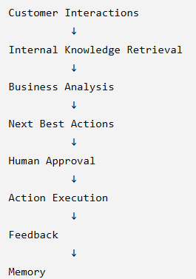
- Customer Journey
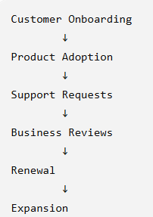
- System Architecture
The platform follows an Agentic AI architecture consisting of multiple specialized agents.
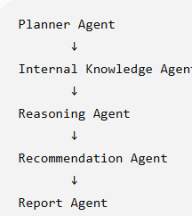
8. Agent Descriptions
8.1 Planner Agent
Responsibilities:
- Understand customer context.
- Decide analysis strategy.
- Determine whether knowledge retrieval is necessary.
- Set analysis priority.

8.2 Internal Knowledge Agent
Responsibilities:
- Retrieve customer information from MongoDB.
- Retrieve support tickets.
- Retrieve emails.
- Retrieve meeting notes.
- Retrieve previous recommendations.
- Retrieve relevant knowledge articles from Qdrant.

8.3 Reasoning Agent
Responsibilities:
- Analyze customer context.
- Calculate customer health.
- Identify risks.
- Identify opportunities.
- Generate business insights.

8.4 Recommendation Agent
Responsibilities:
- Generate Next Best Actions.
- Prioritize recommendations.
- Provide confidence scores.
- Explain reasoning with evidence.

8.5 Report Agent
Responsibilities:
- Generate final customer report.
- Summarize business context.
- Present recommendations.
- Provide executive summary.

  - Technology Stack
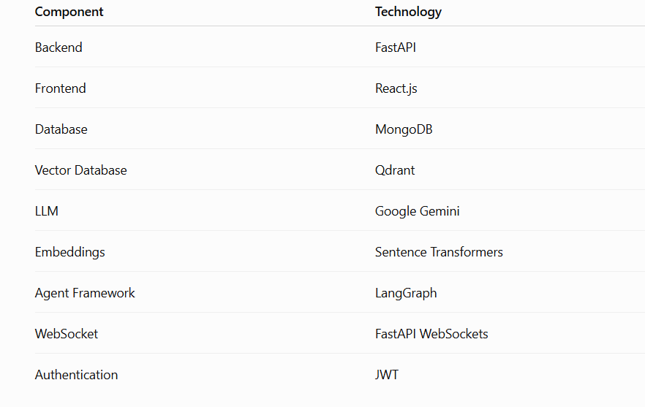

10. Database Design
Customer Collection
Stores:
- Customer information
- ARR
- Industry
- Contract details
- Customer contacts

Interaction Collection
Stores:
- Emails
- Meeting notes
- Support tickets
- Customer conversations

Recommendation Collection
Stores:
- Generated recommendations
- Approval status
- Completion status
- Feedback

Report Collection
Stores:
- Final analysis reports
- Historical reports

11. Knowledge Base
The platform uses an enterprise knowledge base containing:
- Troubleshooting guides
- Playbooks
- Best practices
- Product documentation
- Customer success procedures
Examples:
- Epic EHR Integration Recovery Guide
- Renewal Risk Management Playbook
- Executive Escalation Procedure
- Expansion Opportunity Guide

12. Knowledge Retrieval Process
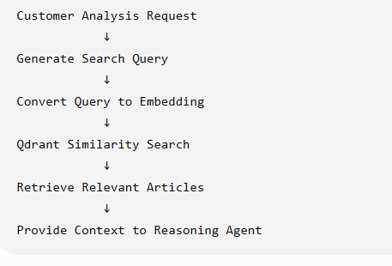
13. Recommendation Lifecycle
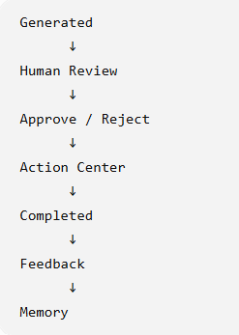
14. Human-in-the-Loop
The platform does not automatically execute recommendations.
Every recommendation requires:
- Human approval
- Human feedback
- Completion confirmation
This ensures safe and explainable decision-making.

15. Memory Mechanism
The platform stores:
- Approved recommendations
- Rejected recommendations
- Completed actions
- Feedback
During future analyses, the platform uses this memory to:
- Avoid duplicate recommendations.
- Learn from previous decisions.
- Generate improved recommendations.

16. Sample Next Best Actions
Examples:
- Execute Epic EHR Recovery Plan.
- Assign Executive Sponsor.
- Schedule Business Value Review.
- Conduct Product Demonstration.
- Prepare Renewal Proposal.

17. Success Metrics
The effectiveness of the platform can be measured using:
- Customer Retention Rate
- Renewal Success Rate
- Churn Reduction
- Expansion Revenue
- Recommendation Acceptance Rate
- Recommendation Completion Rate
- Customer Health Improvement

18. Advantages
- Reduces manual effort.
- Provides explainable recommendations.
- Improves customer retention.
- Identifies business opportunities.
- Supports human decision-making.
- Continuously improves through memory.
- Reusable across different business domains.

19. Future Enhancements
- Multi-customer prioritization dashboard.
- External market intelligence.
- Predictive churn models.
- Automated workflow execution.
- Advanced analytics dashboard.
- Multi-domain support.

20. Conclusion
The Intelligent Next Best Action Platform demonstrates how Agentic AI can transform Customer Success operations by automatically analyzing customer information, retrieving enterprise knowledge, generating explainable recommendations, and learning from historical decisions.
The platform provides a reusable and extensible framework that enables organizations to make faster, more informed, and data-driven customer success decisions while keeping humans in control of critical business actions.

